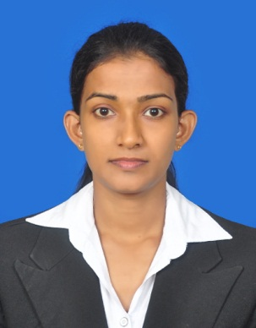

Dhananjaya Sooriya Bandara Aberathne

96, Kawarakkulama

Galkulama

Anuradhapura

dhananjayaaberathne@gmail.com

Madatugama

Mobile No: 0783583678

E-mail: shalikalakmali70@gmail.com

**Profile**:

An individual ready to accept challenges of a dynamic profession with responsibilities associated with it, willing to work very hard to achieve the team goals collaborating with others. I believe that I possess very good in analytical, communication, organizing skills and people skills.

**Career Objectives:**

To be a dynamic professional working in challenging environment that would enable me to enhance and utilize my skills and abilities and venture in the wide range of knowledge leading to self-development and career progression.

**Qualifications / Education:**

**G.C.E. O/L**

**School: A/ Niwatthakachethiya Collage**

**Year: 2012**

**Index No: 23050365**

1. Buddhism A
2. Lang. & Lit ( S ) B
3. Social Sc. & History B
4. Science & Technology C
5. Mathematics C
6. Drama (s) C
7. Information Technology C
8. English S
9. Business & Acc. C

**Other Qualification:**

* I have successfully completed school education software group project which is conducted by the Ministry of education and Microsoft Sri Lanka under the partners in learning programme

**Language Proficiency:**

|  |  |  |  |
| --- | --- | --- | --- |
| Language  English | Spoken  Good | Reading  Good | Writing  Good |
| Sinhala | Excellent | Excellent | Excellent |

**Extra-Curricular Activities**

* I was a member of Rugger team
* I was a member of school cadet
* I was a member of the school prefect board
* I was a member of school Elle team

**Personnel Profile:**

**Full Name** Dhananjaya Sooriya Bandara Aberathne

**Name with Initial** D S B Aberathne

**Gender** Male

**Date of Birth** 1996/06/07

**Race** Sinhalese

**Marital Status** Unmarried

**National Identity Card No.** 961593506**-**V

**Religion** Buddhism

**Referees:**

* **Mr. Susil Amarasiri**

Department of Business Management

Faculty of Management Studies

Rajarata University of Sri Lanka

Email:rkddrandeni@yahoo.com

Contact: 071-8426244/ 025-2266809

* **Mr. Y M W G P K Udurawana**

Senior Lecture

Department of Business Management

Faculty of Management Studies

Rajarata University of Sri Lanka

Email:udurawan@gmail.com

Contact: 077-3322228/ 071-2222296

I do hereby certify that the information given above is true and accurate to the best of my knowledge.

…………………… ………………………

Date Signature